**A**

**MINI PROJECT REPORT**

**ON**

**MOVIE LINE**

**Submitted By**

**K ADITYA-160116737085**

Under the guidance of

MS SMRITI AGARWAL

**Dept. of IT, CBIT.**



**DEPARTMENT OF INFORMATION TECHNOLOGY**

**CHAITANYA BHARATHI   INSTITUTE OF TECHNOLOGY**

**(Affiliated to Osmania University; Accreditated by NBA (AICTE), ISO Certified 9001:2000)**

**Website:** [**www.cbit.ac.in**](http://www.cbit.ac.in)**, www.cbitworld.com**

**HYDERABAD – 500 075**

**2017**

**CHAITANYA BHARATHI   INSTITUTE OF TECHNOLOGY**

DEPARTMENT OF INFORMATION TECHNOLOGY

**(Affiliated to Osmania University)**

**GANDIPET, HYDERABAD – 500 075**



**CERTIFICATE**

This is to certify that the project work titled “**MOVIE LINE**” submitted to **CHAITANYA BHARATHI INSTITUTE OF TECHNOLOGY,** in partial fulfilment of the requirements for the award of the completion of 3rd semester of B.E. in Information Technology, during the academic year 2017-18, is a record of original work done by **K.ADITYA-160116737085** during the period of study in Dept. of IT, CBIT, HYDERABAD, under our supervision and guidance.

**PROJECT GUIDE       HEAD OF THE DEPARTMENT**

**Ms.SMRITHI AGARWAL       Dr.Suresh Pabboju**

Asst. Professor,       Head of the department

Dept. of IT, CBIT.       Information Technology

      C.B.I.T., HYDERABAD

**DECLARATION**

This is to certify that the work reported in the present report titled “**Movie LINE**” is a record of work done by us in the Department of Information Technology, Chaitanya Bharathi Institute of Technology, Hyderabad.

No part of the report is copied from books / journals / internet and wherever the portion is taken, the same has been duly referred. The reported results are based on the project work done entirely by us and not copied from any other source.

**ACKNOWLEDGEMENT**

It is our privilege to acknowledge with deep sense of gratitude and devotion for keen personal interest and invaluable guidance rendered by our Project Guide   **Ms. SMRITHI AGARWAL**,, Department of Information, Chaitanya Bharathi Institute of Technology.

Our respects and regards to **Dr. Suresh Pabboju**, Professor, Department of Information Technology, Chaitanya Bharathi Institute of Technology, for his invaluable suggestions that helped us in successful completion of the project.

We are grateful to our Principal **Dr.P.Ravinder Reddy,** Chaitanya Bharathi Institute of Technology, for his cooperation and encouragement.

Finally, we also thank all the staff members, faculty of Dept. of IT, CBIT, our friends, and all our family members who with their valuable suggestions and support, directly or indirectly helped us in completing this project work.

**ABSTRACT**

**Description-**

Movie LINE, as the name might suggest, is a website for movie lovers to explore and discover new movies based on user's choice and book tickets .Movie LINE suggests the user new and trending movies depending on the release. This website even contains description about every movie so you can read and select the genre based on your mood and book tickets at theatres near you. This way, the user is more inclined to like the movie since the general aesthetic of the movie would be perceived better.. To put it simply, Movie line makes discovering new movies and makes booking tickets simpler.

**Languages -**

* **HTML**- HTML was used to define the basic structure of the website in a user friendly and organised manner
* **Php –is a server side scripting language designed primalily for web development**
* **Mysql is the open source relational sql data base management system.It is used for developing several web based soft ware application.**

**CONTENTS**

**Page No.**

Abstract . . . . . . . . . . . . . . . . . . . . . . . . . . . . . . . . . . . . . . . . . . . . . . . . . . . . . . . . . . . . .

Contents. . . . . . . . . . . . . . . . . . . . . . . . . . . . . . . . . . . . . . . . . . . . . . . . . . . . . . . . . . . .

List of Figures . . . . . . . . . . . . . . . . . . . . . . . . . . . . . . . . . . . . . . . . . . . . . . . . . . . . . . . .

1. **Introduction.** . . . . . . . . . . . . . . . . . . . . . . . . . . . . . . . . . . . . . . . . . . . . . . . . . . . . . . .

1.1. Overview. .  . . . . . . . . . . . . . . . . . . . . . . . . . . . . . . . . . . . . . . . . . . . . . . . . . .

1.2. Aim of Project. . . . . . . . . . . . . . . . . . . . . . . . . . . . . . . . . . . . . . . . . . . . . . . . .

1.3. Organization of the Report. . . . . . . . . . . . . . . . . . . . . . . . . . . . . . . . . . . . . . .

**2. Technologies . . . . . . . . . . . . . . .** . . . . . . . . . . . . . . . . . . . . . . . . . . .  . . . . . . . . . . . .

2.1. About HTML . . . . . . . . . . . . . . . . . . . . . . . . . . . . . . . . . . . . . . . . . . . . . . . . .

2.1.1. Introduction  . . . . . . . . . . . . . . . . . . . . . . . . . . . . . . . . . . . . . . . . . .

          2.1.2. HTML Basic tags . . .  . . . . . . . . . . . . . . . . . . . . . . . . . . . . . . . . . . .

                        2.1.3. HTML ATTRIBUTES . . . . . . . . . . . . . . . . . . . . . . . . . . . . . . . . . .

           2.1.4. HTML Images . . . . . . . . . . . . . . . . . . . . . . . . . . . . . . . . . . . . . . . . .

2.1.5. HTML Tables . . . . . . . . . . . . . . . . . . . . . . . . . . . . . . . . . . . . . . . . .

2.1.6. HTML Forms . . . . . . . . . . . . . . . . . . . . . . . . . . . . . . . . . . . . . . . . .

**3. Software Requirement Specification** . . . . . . . . . . . . . . . . . . . . . . . . . . . . . . . . . . . .

3.1. Introduction . . . . . . . . . . . . . . . . . . . . . . . . . . . . . . . . . . . . . . . . . . . .  . . . . . .

3.1.1 Purpose of the document . . . . . . . . . . . . . . . . . . . . . . . . . . . . . . . . .

3.1.2 Scope of the document . . . . . . . . . . . . . . . . . . . . . . . . . . . . . . . . . .

3.2. Users and their Characteristics . . . . . . . . . . . . . . . . . . . . . . . . . . . . . . . . . . .

3.3. Functional Requirements . . . . . . . . . . . . . . . . . . . . . . . . . . . . . . . . . . . . . . .

3.4. Software and Hardware Requirements. . . . . . . . . . . . . . . . . . . . . . . . . . . . . .

**4. Implementation** . . . . . . .  . . . . . . . . . . . . . . . . . . . . . . . . . . . . . . . . . . . . . . . . . . . . . . .

4.1. Introduction . . . . . . . . . . . . . . . . . . . . . . . . . . . . . . . . . . . . . . . . . . . . . . . . . . . .

4.3. HTMLphp mysql. . . . . . . . . . . . . . . . . . . . . . . . . . . . . . . . . . . . . . . . . . . . . . . . . .

**5. Testing and Results** . .   . . . . . . . . . . . . . . . . . . . . . . . . . . . . . . . . . . . . . . . . . . . . . . . .

5.1. Introduction . . . . . . . . . . . . . . . . . . . . . . . . . . . . . . . . . . . . . . . . . . . . . . . . . . . . . . . .

5.2. Testing Objectives . . . . . . . . . . . . . . . . . . . . . . . . . . . . . . . . . . . . . . . . . . . . . . .

5.3. Output Screens . . . . . . . . . . . . . . . . . . . . . . . . . . . . . . . . . . . . . . . . . . . . . . . . . .

**6. Conclusion and Future Scope** . . . . . . . . . . . . . . . . . . . . . . . . . . . . . . . . . . . . . . . . . . .

**Bibliography** . . . . . . . . . . . . . . . . . . . . . . . . . . . . . . . . . . . . . . . . . . . . . . . . . . . . . . . . . . .

**1. INTRODUCTION**

* 1. **OVERVIEW**

Movie line is a website developed using HTML,php and sql data base .which lets user to find movie based on their genre and helps us to book tickets. This way the user finds movie they are more inclined to like. Movie line also provides the people who have logged in it.

HTML is used to develop the Web page and by wamp server using php and sql we have stored the data.

* 1. **AIM OF THE PROJECT**

As our tagline “A Platforn Where You Can Eperience New Movies” suggests the user to book new movies, Movie line was started with the simple goal of making booking movie tickets easier. With 'Movie line ’ user friendly interface, the user gets helpful, easy and fun way to explore Movies.

* 1. **ORGANISATION OF REPORT**

The organization of the report is as follows:

**Chapter 1** deals with the Introduction of the project and gives the details about the project in an abstract view.

**Chapter 2** deals with the information about HTML,php mysql utilization details are discussed in brief.

**Chapter 3** deals with the Software Requirements Specifications which is a specification of the project software and hardware requirements.

**Chapter 4** deals with the Implementation part which includes the tools and softwares that are used.

**Chapter 5** deals with the Testing of the project and screenshots of the project

**Chapter 6** explains the Conclusion and further scope of the project.

1

**2. TECHNOLOGIES**

**2.1 ABOUT HTML**

**2.1.1 INTRODUCTION**

            HTML stands for **H**yper **T**ext **M**arkup **L**anguage, which is the most widely used language on Web to develop web pages.

* **Hypertext** refers to the way in which Web pages (HTML documents) are linked together. Thus the link available on a webpage are called Hypertext.
* As its name suggests, HTML is a **Markup Language** which means you use HTML to simply "mark up" a text document with tags that tell a Web browser how to structure it to display.

Originally, HTML was developed with the intent of defining the structure of documents like headings, paragraphs, lists, and so forth to facilitate the sharing of scientific information between researchers.

* + 1. **HTML Basic Tags**

Any document starts with a heading. You can use different sizes for your headings. HTML also has six levels of headings, which use the elements **<h1>, <h2>, <h3>, <h4>, <h5>, and <h6>**. While displaying any heading, browser adds one line before and one line after that heading.

1. The **<p>** tag offers a way to structure your text into different paragraphs. Each paragraph of text should go in between an opening <p> and a closing </p>tag .

Whenever you use the **<br />** element, anything following it starts from the next line. This tag is an example of an **empty** element, where you do not need opening and closing tags, as there is nothing to go in between them.

You can use **<center>** tag to put any content in the center of the page or any table cell.

2

**2.1.3 HTML ATTRIBUTES**

An attribute is used to define the characteristics of an HTML element and is placed inside the element's opening tag. All attributes are made up of two parts: a **name** and a **value**:

* The **name** is the property you want to set. For example, the paragraph <p> element in the example carries an attribute whose name is **align**, which you can use to indicate the alignment of paragraph on the page.
* The **value** is what you want the value of the property to be set and always put within quotations. The below example shows three possible values of align attribute: **left, center** and **right**.

Attribute names and attribute values are case-insensitive. However, the World Wide Web Consortium (W3C) recommends lowercase attributes/attribute values in their HTML 4 recommendation.

**CORE ATTRIBUTES**

1. **id Attribute**

The **id** attribute of an HTML tag can be used to uniquely identify any element within an HTML page. There are two primary reasons that you might want to use an id attribute on an element:

* If an element carries an id attribute as a unique identifier it is possible to identify just that element and its content.
* If you have two elements of the same name within a Web page (or style sheet), you can use the id attribute to distinguish between elements that have the same name.

1. **Title Attribute**

The **title** attribute gives a suggested title for the element.The behavior of this attribute will depend upon the element that carries it, although it is often displayed as a tooltip when cursor comes over the element or while the element is loading.

3

**2.1.4 HTML IMAGES**

Images are very important to beautify as well as to depict many complex concepts in simple way on your web page.

**INSERT IMAGES**

You can insert any image in your web page by using **<img>** tag. Following is the simple syntax to use this tag.

<imgsrc="Image URL" ... attributes-list/>

**SET IMAGE WIDTH /HEIGHT**

You can set image width and height based on your requirement using **width** and **height** attributes. You can specify width and height of the image in terms of either pixels or percentage of its actual size.

**2.1.5 HTML TABLES**

The HTML tables allow web authors to arrange data like text, images, links, other tables, etc. into rows and columns of cells.

The HTML tables are created using the **<table>** tag in which the **<tr>** tag is used to create table rows and **<td>** tag is used to create data cells.

**TABLE HEADING**

Table heading can be defined using **<th>** tag. This tag will be put to replace <td> tag, which is used to represent actual data cell. Normally you will put your top row as table heading , otherwise you can use <th> element in any row.

**TABLE CAPTION**

The **caption** tag will serve as a title or explanation for the table and it shows up at the top of the table.

**2.1.6. HTML FORMS**

## The <form> Element:The HTML <form> element defines a form that is used to collect user input.

4

## 1.The <input> Element

The **<input>** element is the most important form element and can be displayed in several ways, depending on the **type** attribute.

|  |  |
| --- | --- |
| **Type** | **Description** |
| <input type="text"> | Defines a one-line text input field |
| <input type="radio"> | Defines a radio button (for selecting one of many choices) |
| <input type="submit"> | Defines a submit button (for submitting the form) |

## 2.The Action Attribute

The **action** attribute defines the action to be performed when the form is submitted.Normally, the form data is sent to a web page on the server when the user clicks on the submit button. The form data is sent to a page on the server called "/action_page.php". This page contains a server-side script that handles the form data:

<form **action="/action_page.php**">

**3.The Method Attribute**

The **method** attribute specifies the HTTP method (**GET**or **POST**) to be used when submitting the form data:

<form action="/action_page.php" **method="POST"**>

5

**7**

**3. SOFTWARE REQUIREMENT SPECIFICATION**

* 1. **INTRODUCTION**

The requirements specification is a technical specification of requirements for the software products. It is the first step in the requirements analysis process it lists the requirements of a particular software system including functional, performance and security requirements. The requirements also provide usage scenarios from a user, an operational and an administrative perspective. The purpose of software requirements specification is to provide a detailed overview of the software project, its parameters and goals. This describes the project target audience and its user interface, hardware and software requirements. It defines how the client, team and audience see the project and its functionality.

* + 1. **Purpose of the document**

This software requirement specification describes all the requirements elicited for “MOVIE BUFF” and is intended to be used by the members examining the project and implementing and verifying the application. Unless otherwise noted all requirements are of high priority and are committed.

**3.2. USERS AND THEIR CHARACTERISTICS**

Movie Buff website is useful to users who are looking for new music in an interactive way.

**3.3 SOFTWARE AND HARDWARE REQUIREMENTS**

|  |  |
| --- | --- |
| Operating System | Windows XP or higher version |
| Programming Languages | HTML,CSS, JavaScript |
| Processor | Intel(R) Core(TM) i3 CPU M 350 @2.27GHz |
| RAM | 1 GB or more |
| Disk Space | 1GB or more |

13

**4. IMPLEMENTATION**

**4.1 INTRODUCTION**

The success of the software product is determined only when it is successfully implemented according to the requirements. The analysis and the design of the proposed system provide a perfect platform to implement the idea using the specified technology in the desired environment. The implementation of our system is made user friendly.

Any software project is designed in modules and the project is said to be successfully implemented when each of the module is executed individually to obtain the expected result and also, when all the modules are integrated and run together without any errors.

**4.2 HTML**

HTML was used to build the basic structure and display the contents of the WebPages in the website. The basic structure of home page of the website and the articles were built using HTML. They have slight differences in their structures. It includes the CSS and Java Script files required for the website.

**5. TESTING AND RESULTS**

**5.1    INTRODUCTION**

Software testing is a critical element of software quality assurance and represents the ultimate review of specification, design and coding. In fact, testing is the one step in the software engineering process that could be viewed as destructive rather than constructive.

A strategy for software testing integrates software test case design methods into a well-planned series of steps that result in the successful construction of software. Testing is the set of activities that can be planned in advance and conducted systematically. The underlying motivation of program testing is to affirm software quality with methods that can economically and effectively apply to both strategic to both large and small-scale systems.

**5.2 TESTING OBJECTIVES**

The main objective of  performance testing is designed to test whether the website’s display is as expected and whether the website is functioning properly or not.

As the test results are gathered and evaluated they begin to give a qualitative indication of the reliability of the website. If proper output is not obtained, the overall quality of the Website is questioned. If, on the other hand, all the results which are not successful, are encountered, and are easily modifiable, then the following conclusion can be made: The tests are inadequate as the requirements mentioned are not compatible. The testing includes:

* Checking whether the information is displayed or not.
* Checking whether all the links between each webpage in the website works or is misdirected.
* Verifying if all the pictures are displayed and none of the files are corrupted.

16

**5.3. OUTPUT SCREENS:**

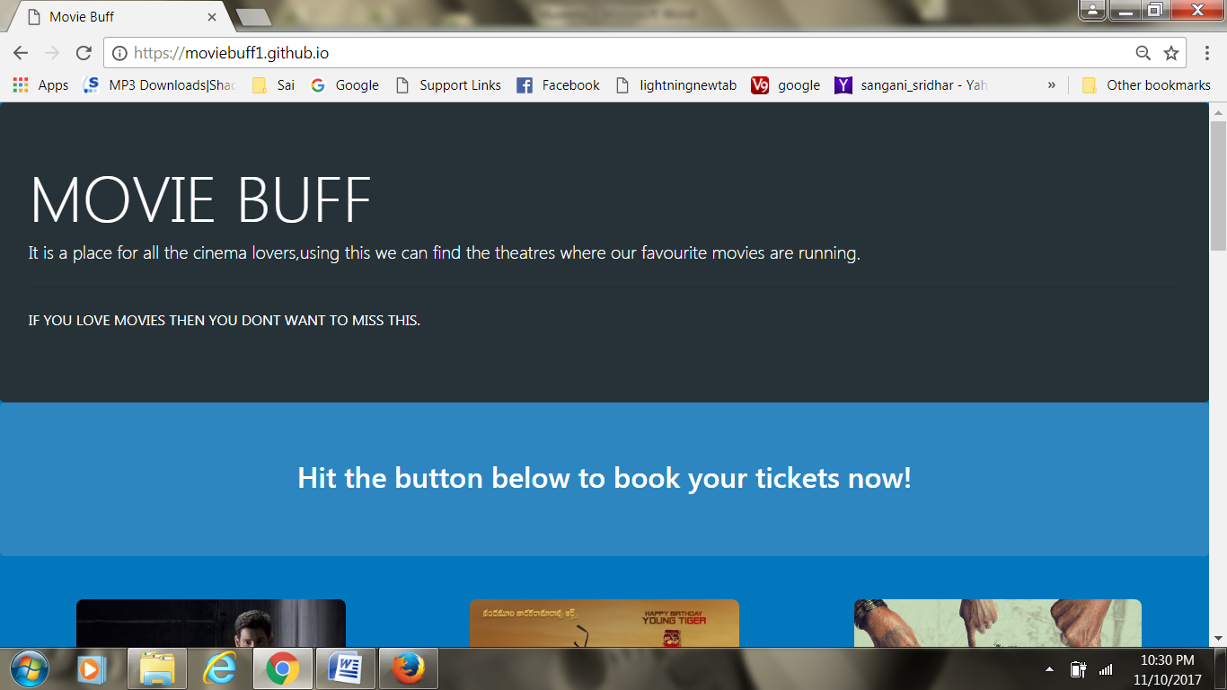

**Fig 5.1.HOME Page**

The above figure shows the home page of the website containing ‘Book Now’ Button and the overview of the page

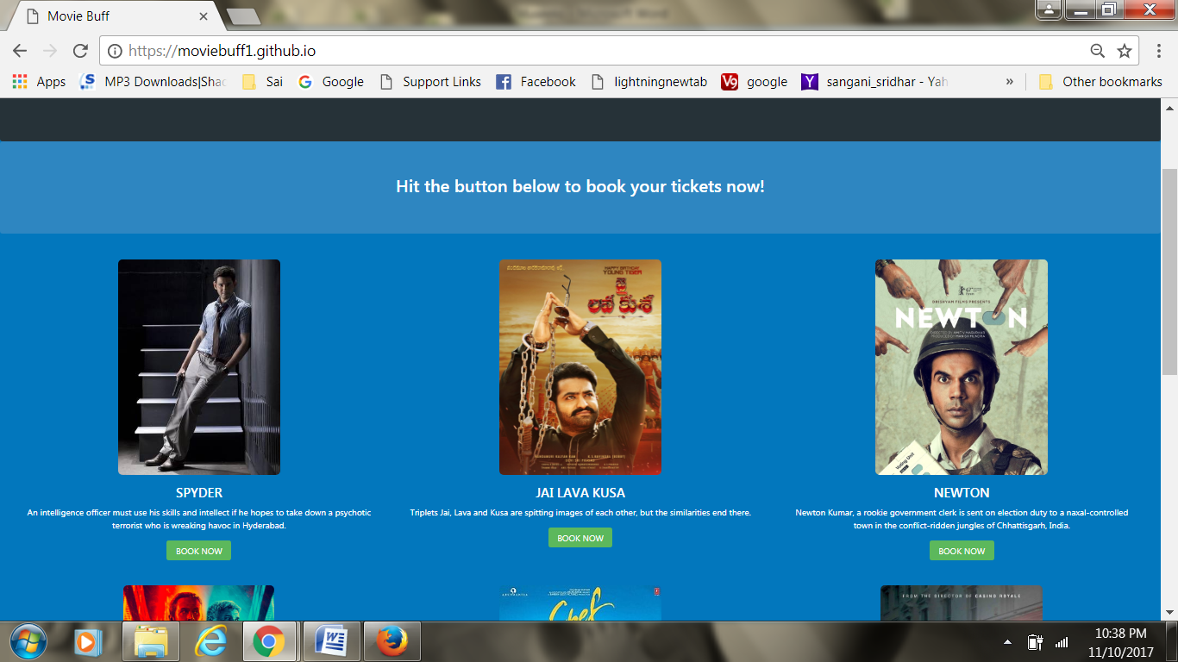

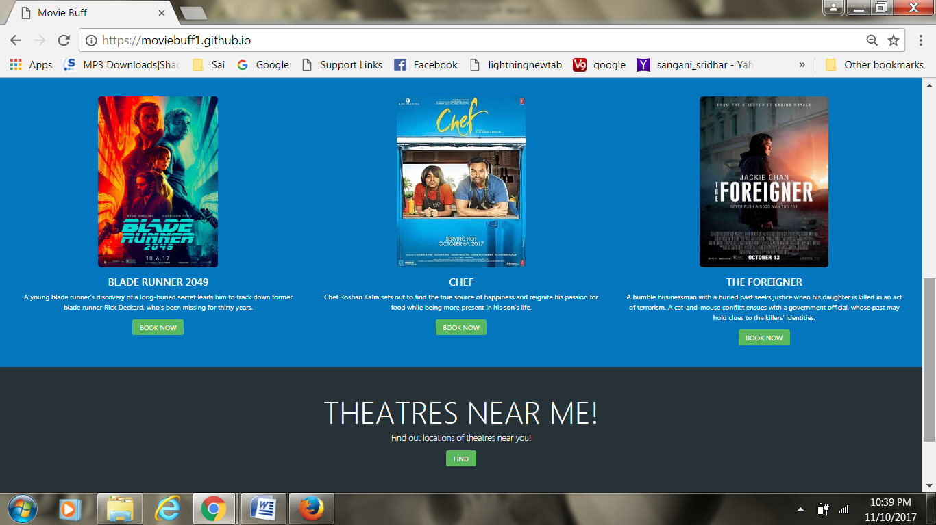

**Fig 5.2.**

The above two images are for to get a list of movies you want to book.

**6. CONCLUSION AND FUTURE SCOPE**

Our website “movie line ” is designed in such a way that future modifications can be done easily. The following conclusion can be deduced from the development of our project.

* Division of movies, based on their release makes booking tickets simpler.
* A friendly user-interface makes the user stay on the website and try different features.
* Then we can find who all have logged in..

. Using our website the users can *book the tickets of movies they want to watch .*This is a place for all cinema lovers using this we can find theatres where our favourite movies.

22

**7. BIBLIOGRAPHY**

**Websites:**

[1] https://www.w3schools.com/html/default.asp

[2] https://www.w3schools.com/php/default.asp

[3] https://www.w3schools.com/mysql/default.asp

23